Housing Society Management System

Design Document

Version 1.0



Group ID: F25PROJECT610E7
Supervisor Name: Haseeb Akmal

Revision History
Date (dd/mm/yyyy) | Version | Description | Author
26/12/2025 | 1.0 | The Housing Society Management System (HSMS) is designed to serve as a centralized digital platform that automates and simplifies the day-to-day administrative tasks of a residential community. It aims to maintain accurate records of residents, property details, ownership history, tenancy information, and unit-related data to ensure smooth management operations. | BC220201543

Table of Contents
Introduction of Design Document 5
Entity Relationship Diagram (ERD) 6
Sequence Diagrams 7
Users Login 7
Admin – System Owner / Management Role 8
User & Property Management 8
Financial Management 9
Complaint & Service Management 10
Notice & Communication 11
Amenity Management & Security Oversight 12
2. Resident – End User / Society Member 13
Unit & Membership & Billing & Payments 13
Complaints & Requests & Amenity Booking 14
Communication & Engagement & Emergency (SOS) 15
3. Security Guard – Operational / Gatekeeping Role 16
Visitor Entry & Exit Management & Staff & Vendor Tracking & Gate & Patrol Operations 16
Architecture Design Diagram 17
Class Diagram 18
Database Design 19
Interface Design 20
Login 20
Admin Dashboard 21
Resident Dashboard 21
Test Cases 22
TC_01: Admin Login 22
TC_02: Admin Update Profile 22
TC_03: Create Resident 22
TC_04: Update Resident 23
TC_05: Assign Resident to Unit 23
TC_06: Create Staff/Vendor 23
TC_07: Generate Bill 24
TC_08: Record Payment 24
TC_09: View Income/Expense Report 24
TC_10: Create Complaint 25
TC_11: Assign Complaint 25
TC_12: Update Complaint Status 25
TC_13: Create Notice 26
TC_14: Create Poll 26
TC_15: Create Amenity 26
TC_16: Approve Amenity Booking 27
TC_17: Security Guard Login 27
TC_18: Register Visitor Entry 27
TC_19: Register Visitor Exit 27
TC_20: Guard Patrol Logging 28
TC_21: Resident Login 28
TC_22: View Unit Details 28
TC_23: View Bills 29
TC_24: Pay Bill 29
TC_25: Raise Complaint 29
TC_26: Book Amenity 30
TC_27: View Notices 30
TC_28: Trigger SOS 30
TC_29: Guard Receives SOS 31
TC_30: Generate Defaulter List 31

Introduction of Design Document
The design document plays a crucial role in the software development lifecycle, serving as a blueprint that guides developers in implementing the envisioned system. This document outlines the structure, architecture, and key functionalities of our project. It provides a comprehensive overview of the proposed solution, ensuring that all stakeholders have a clear understanding of the system's design before development begins.

Purpose of design phase:

- Clarity and Consistency:
The design phase aims to establish a clear and consistent vision for the web application. By detailing the system architecture, data flow, and user interfaces, the design document ensures that developers, designers, and other stakeholders are on the same page regarding the project's objectives.
- Blueprint for Development:
The design document serves as a blueprint that developers can follow during the implementation phase. It provides a structured approach to coding, helping to minimize errors and ensuring that the final product aligns with the client's requirements.
- Risk Mitigation:
Identifying potential challenges and risks early in the design phase allows for proactive planning and mitigation strategies. This reduces the likelihood of unexpected issues arising during development and helps maintain project timelines.
- Communication Tool:
The design document acts as a communication tool between different teams and stakeholders. It facilitates discussions on architecture, functionalities, and user experience, fostering collaboration and ensuring everyone involved is well-informed.

Benefits of the design phase:
- Reduced Development Costs:
Early identification of design flaws and improvements helps prevent costly rework during the development phase.
- Improved Collaboration:
Clear documentation fosters better communication between development teams, designers, and stakeholders, leading to a more cohesive and successful project.
- Enhanced User Experience:
A well-thought-out design document ensures that user interfaces are intuitive and aligned with user expectations, resulting in a positive user experience.
- Risk Management:
Anticipating and addressing potential risks at the design stage allows for proactive risk mitigation, reducing the likelihood of issues affecting the project timeline and budget.

- Client Confidence:
A detailed design document instills confidence in clients by providing a tangible representation of the proposed solution, allowing them to visualize the final product before development begins.

Entity Relationship Diagram (ERD)

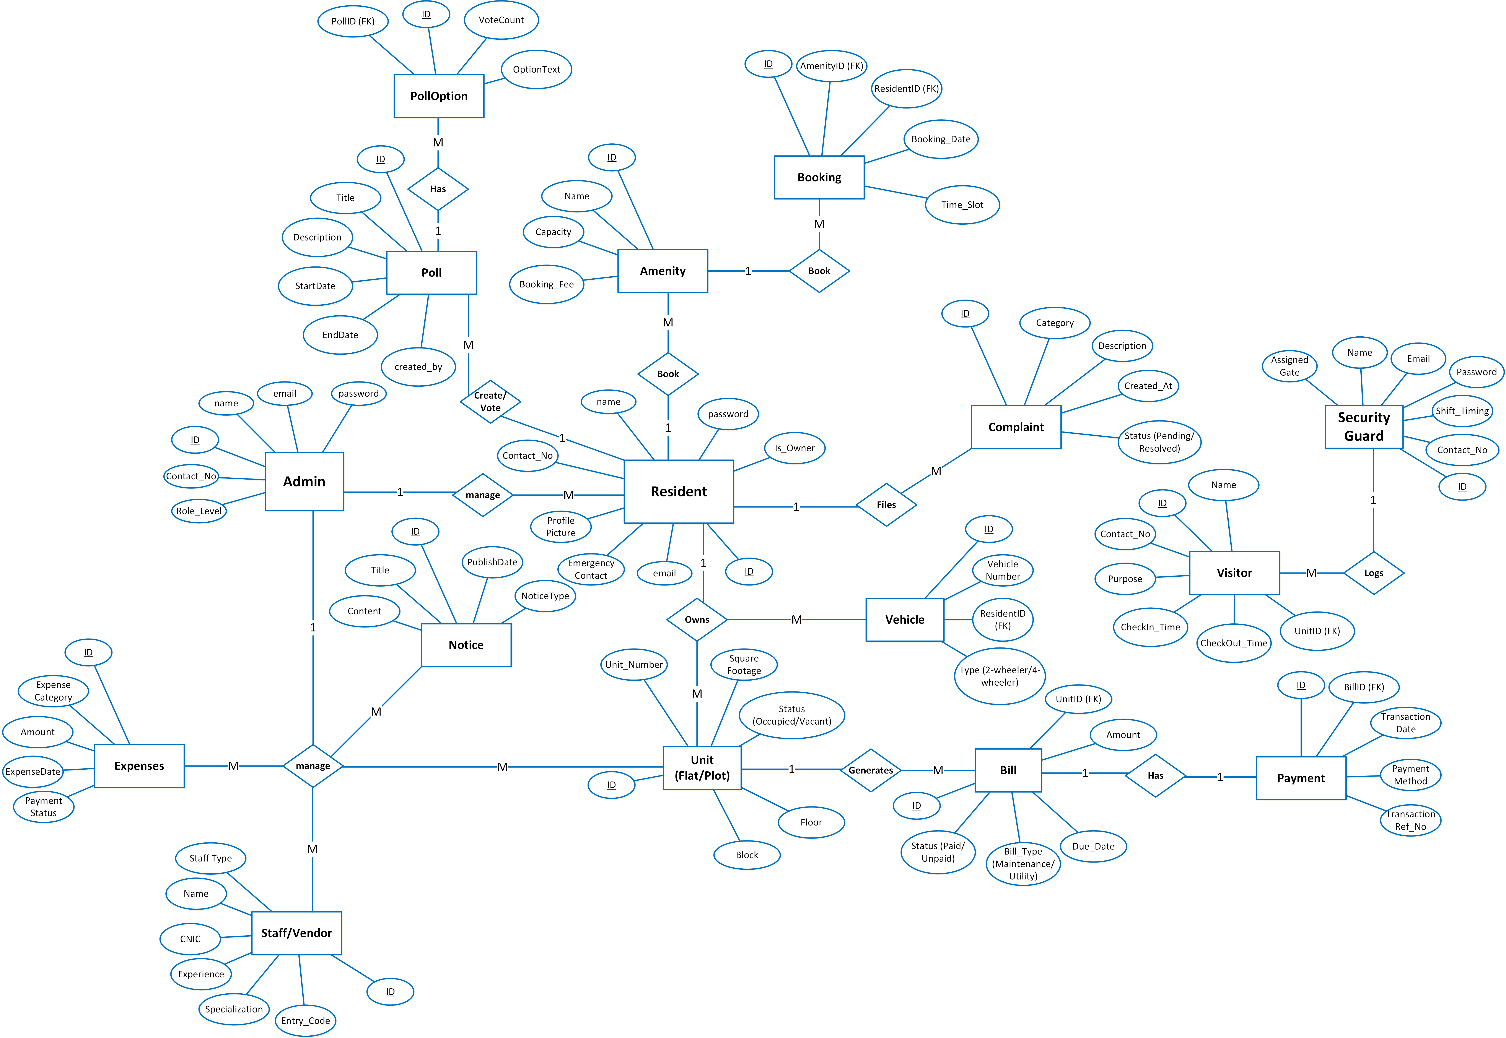

Sequence Diagrams

Users Login
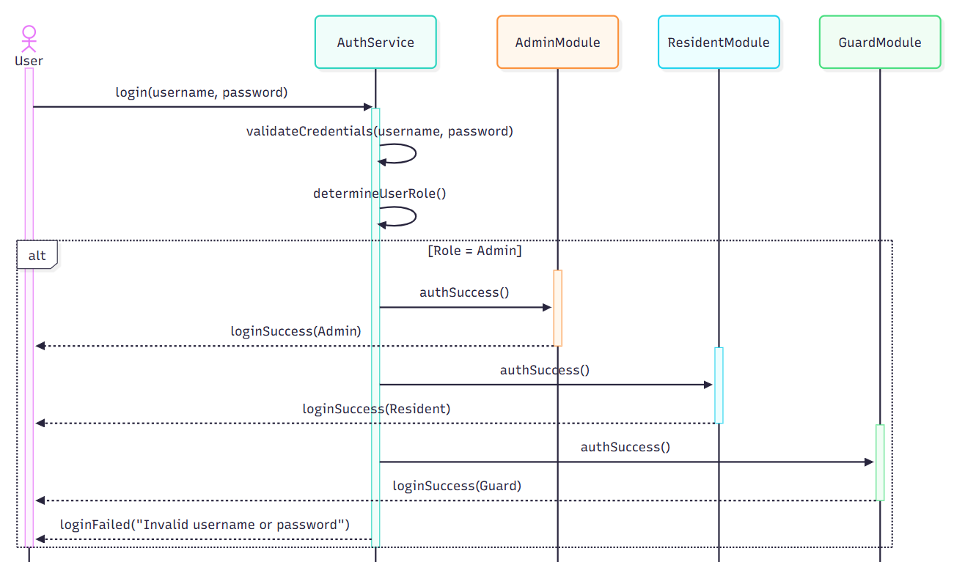

Admin – System Owner / Management Role

User & Property Management

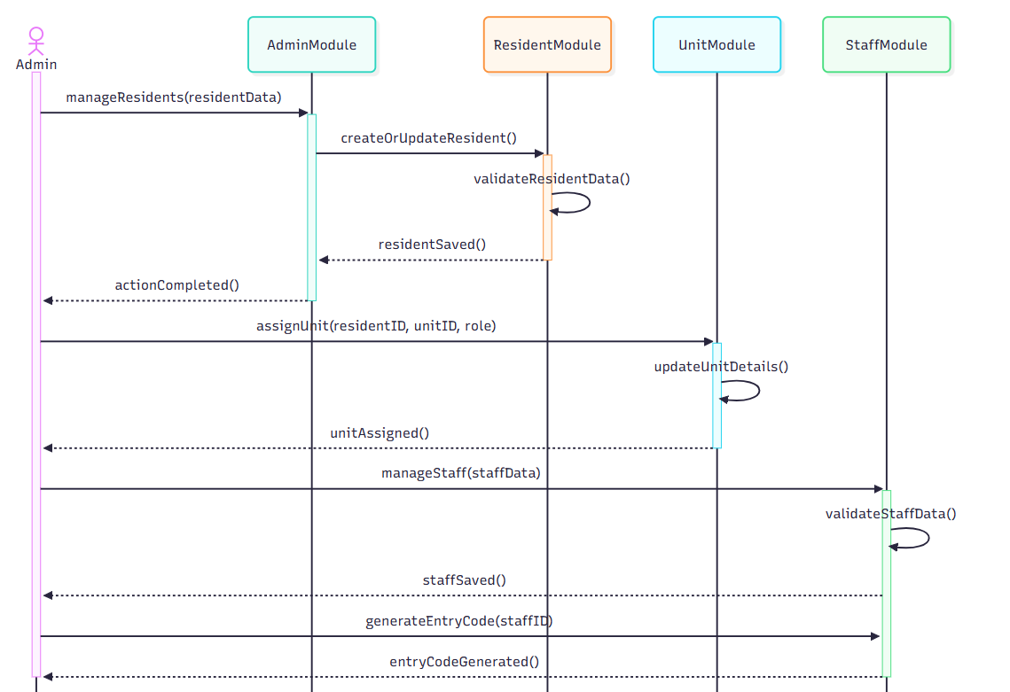

Financial Management

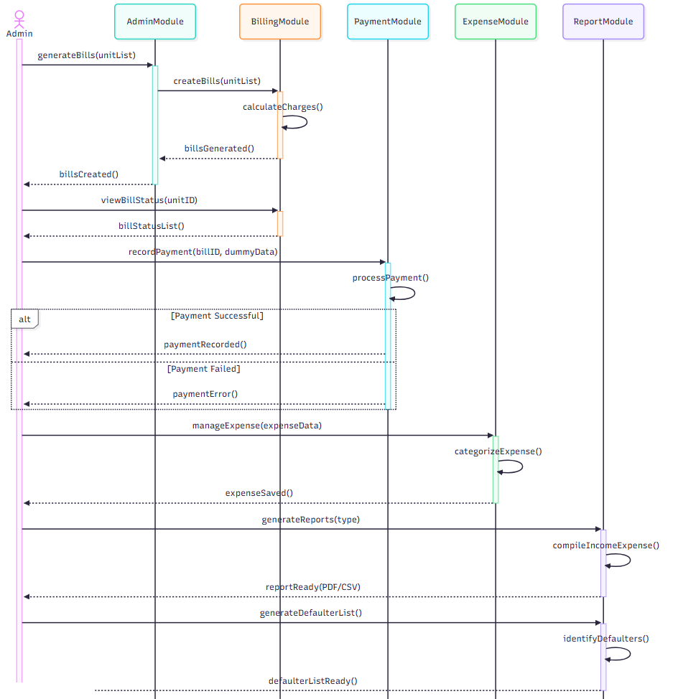

Complaint & Service Management

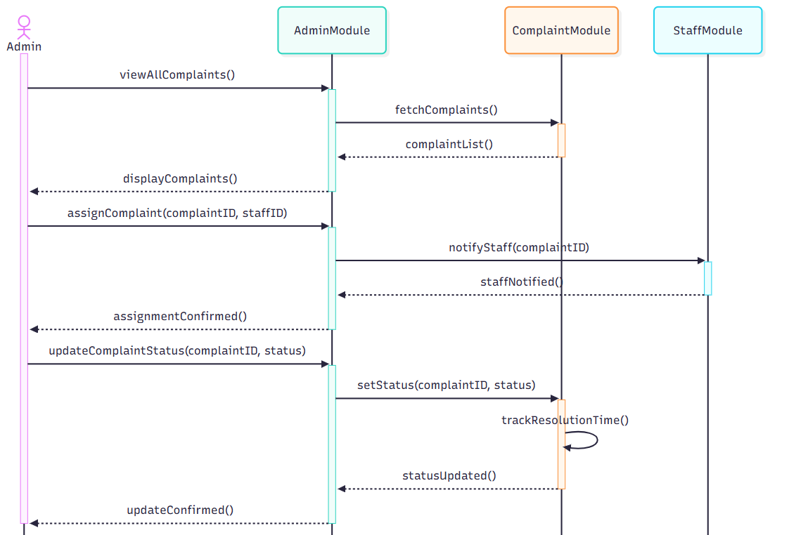

Notice & Communication
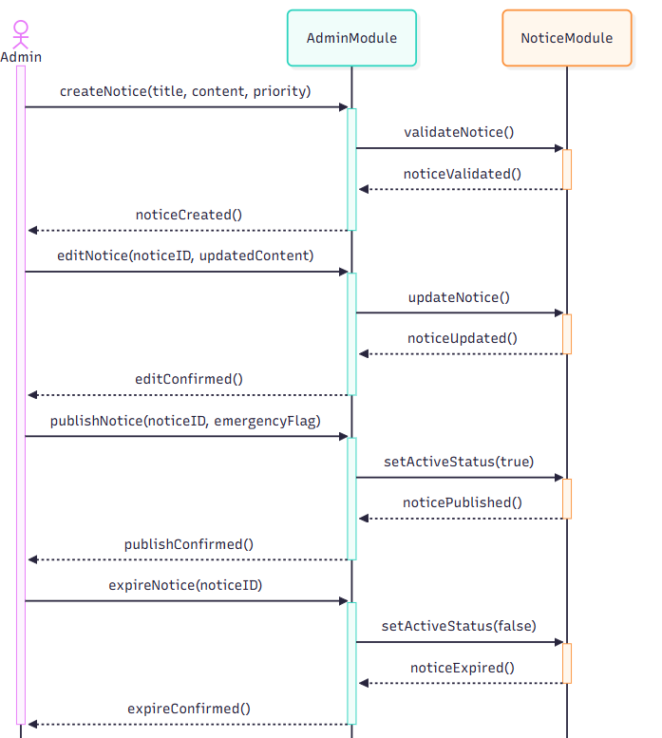

Amenity Management & Security Oversight

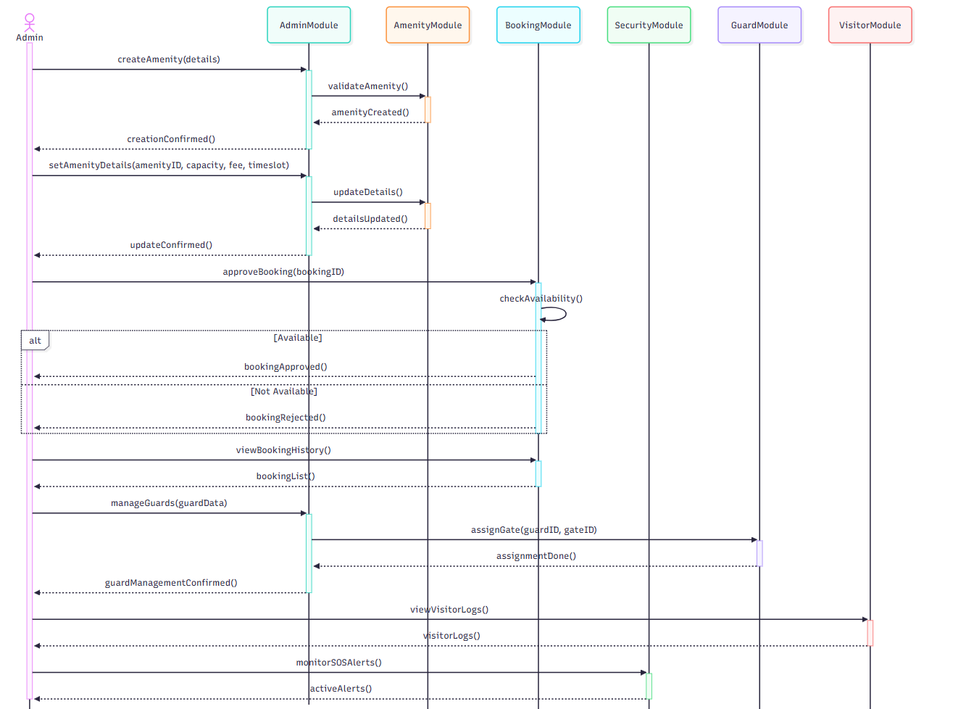

2. Resident – End User / Society Member

Unit & Membership & Billing & Payments
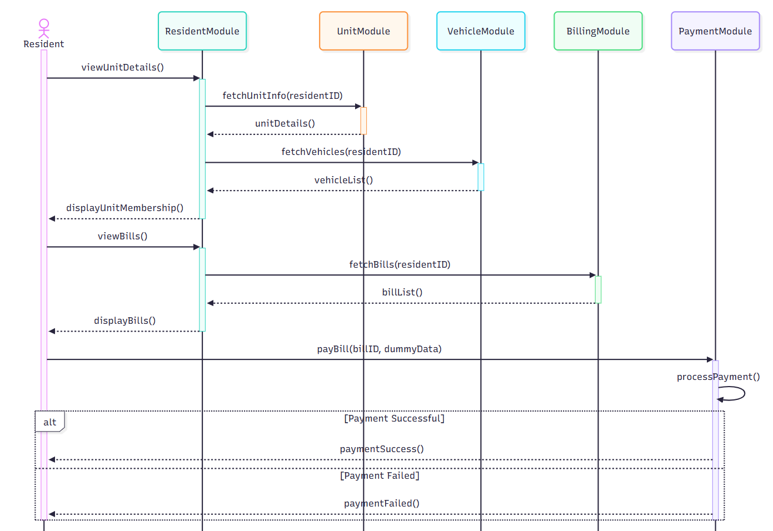

Complaints & Requests & Amenity Booking

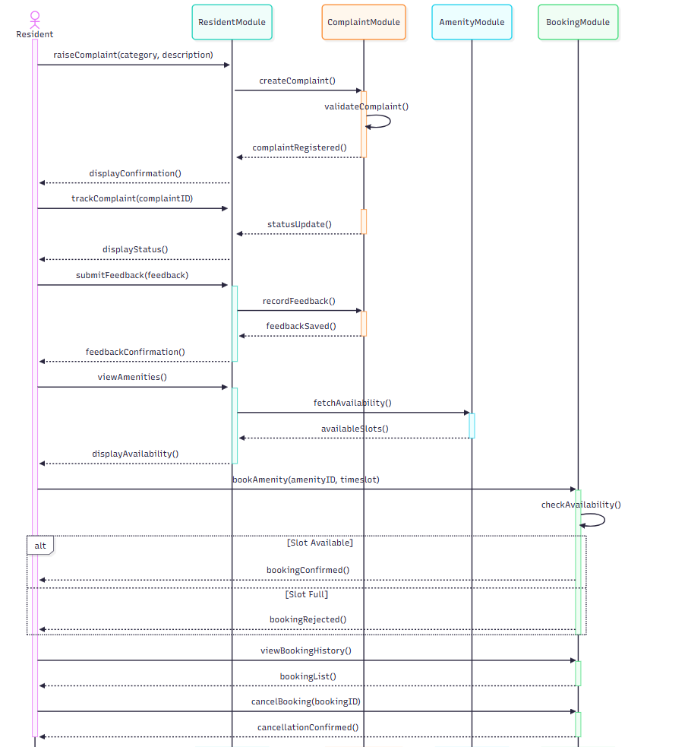

Communication & Engagement & Emergency (SOS)

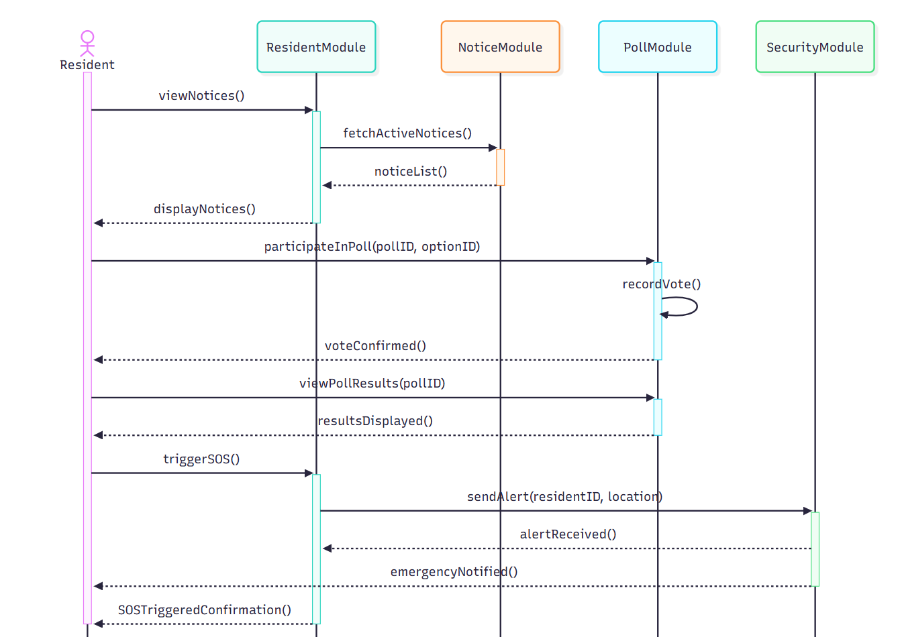

3. Security Guard – Operational / Gatekeeping Role

Visitor Entry & Exit Management & Staff & Vendor Tracking & Gate & Patrol Operations
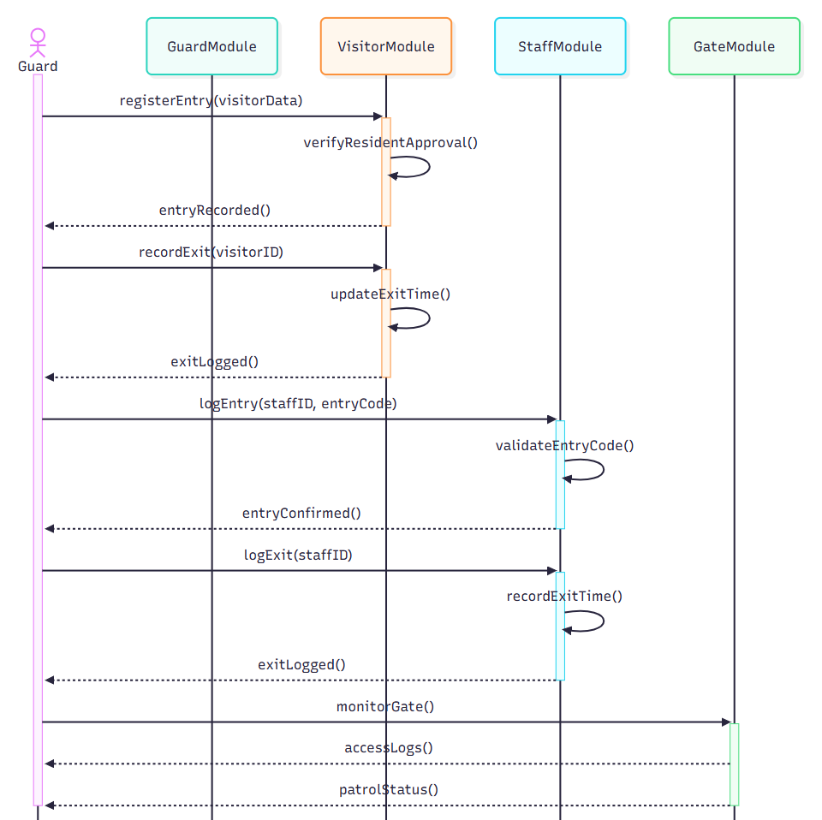

Architecture Design Diagram

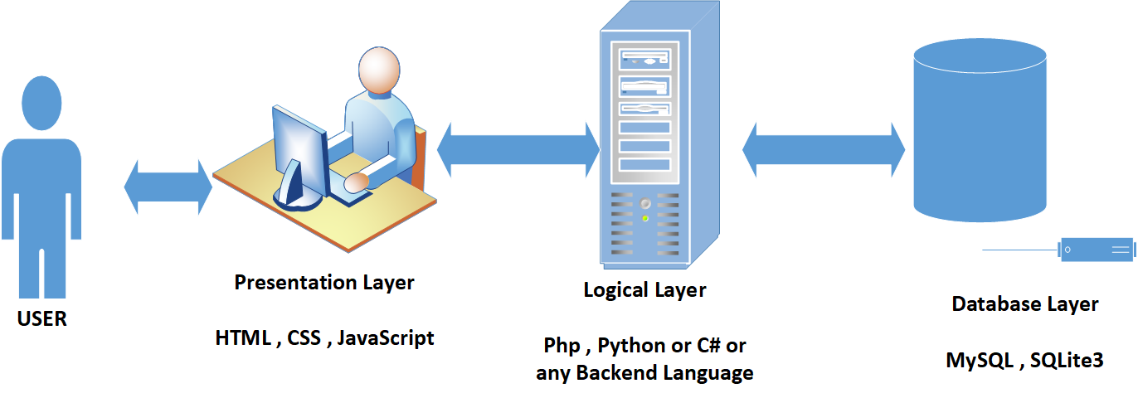

Class Diagram

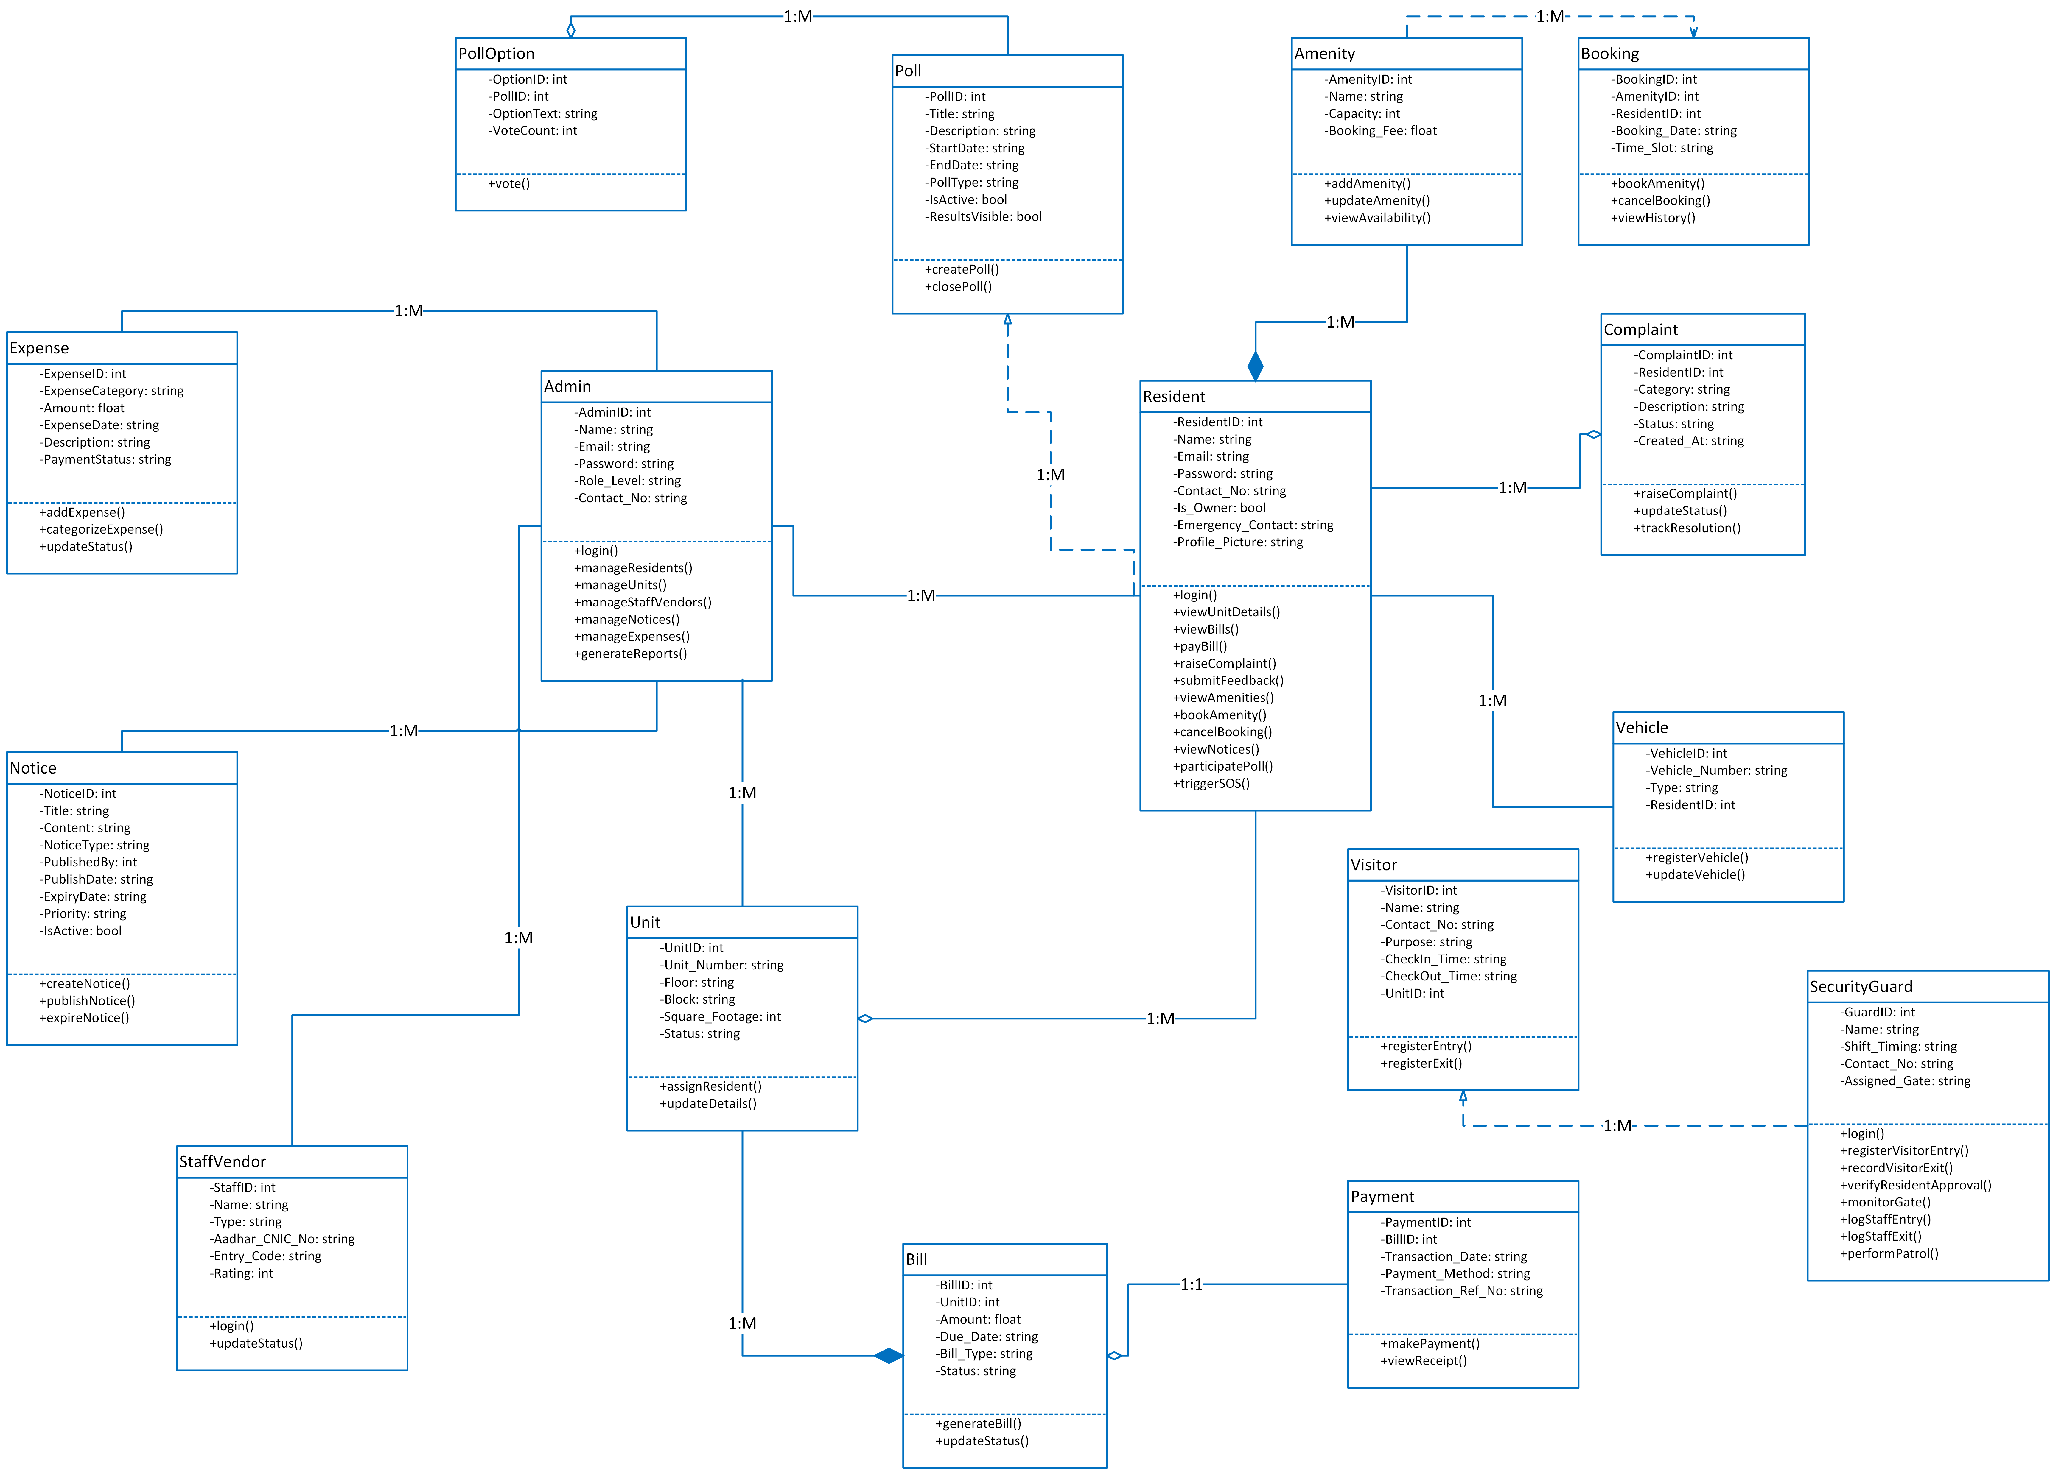

Database Design

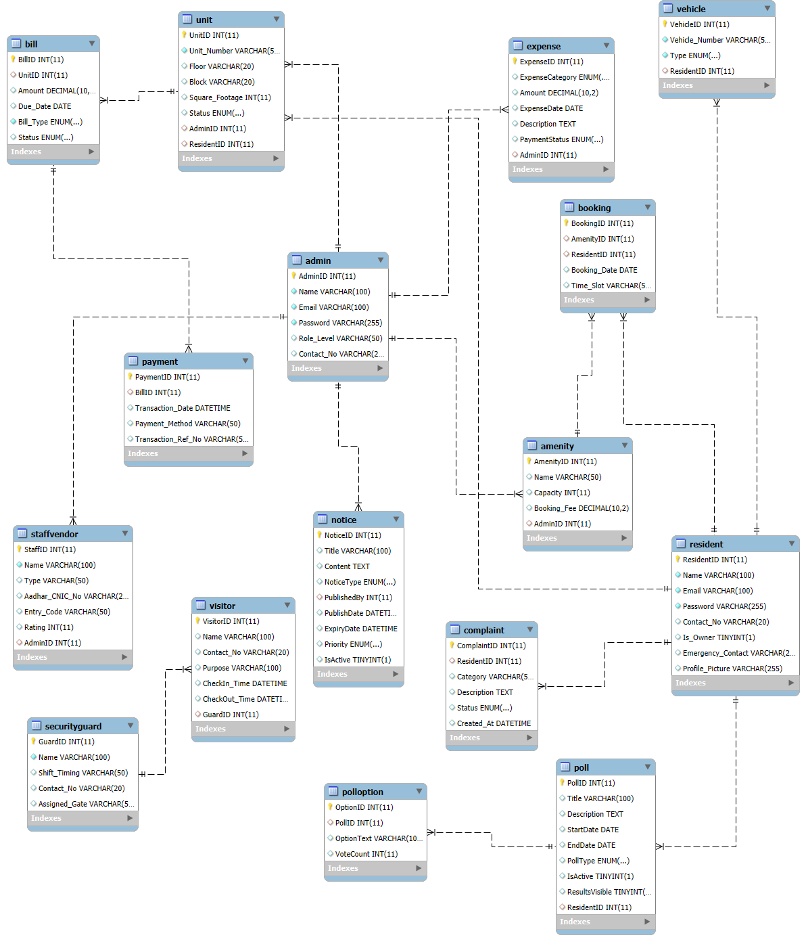

Interface Design

Login

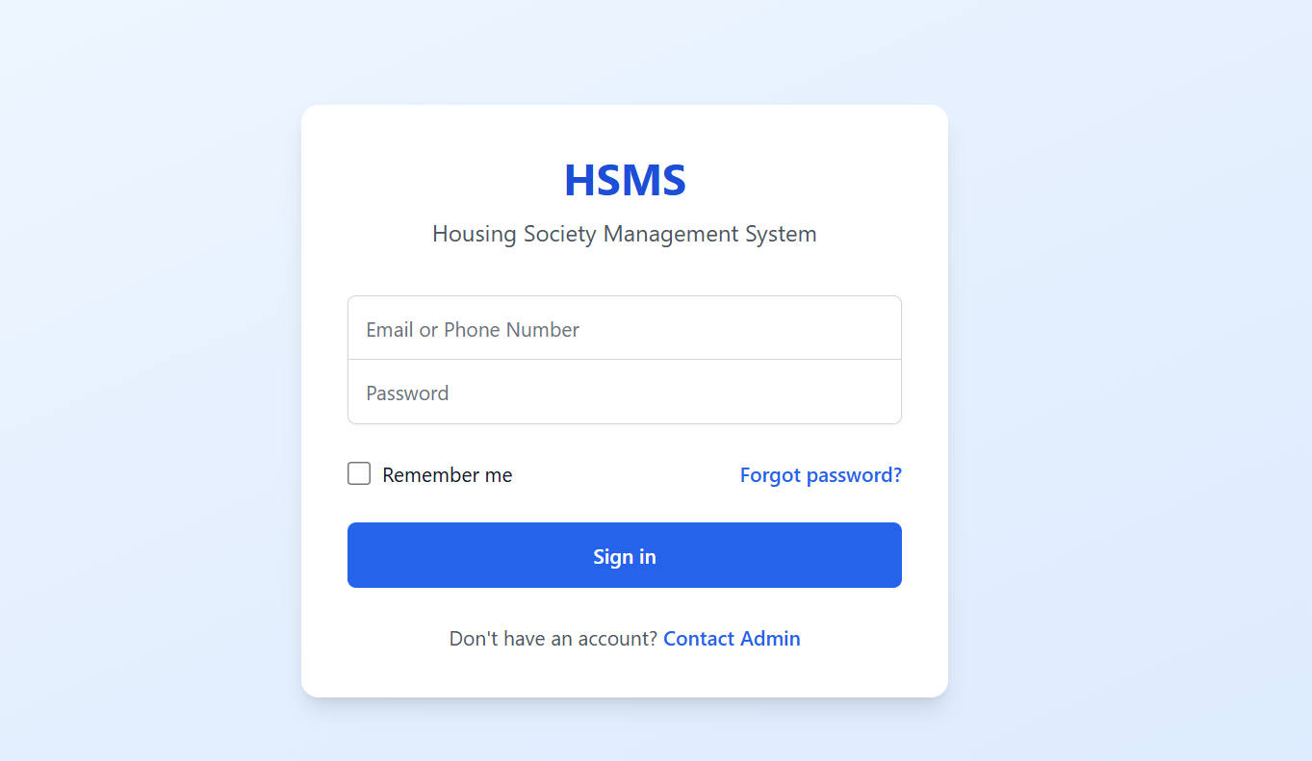

Admin Dashboard

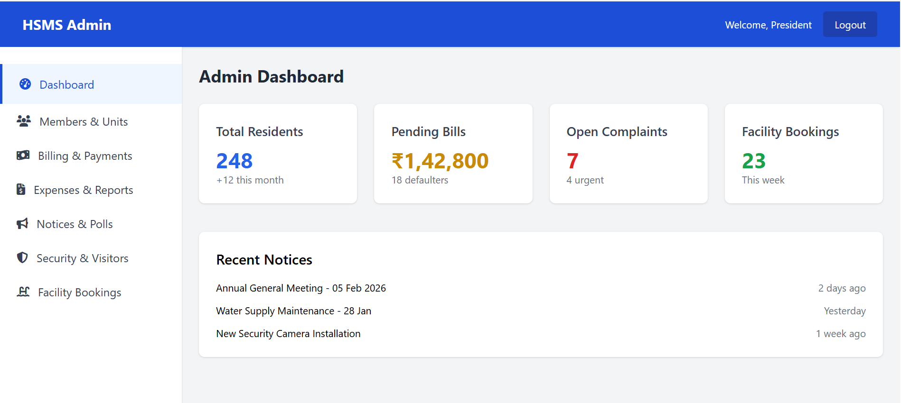

Resident Dashboard

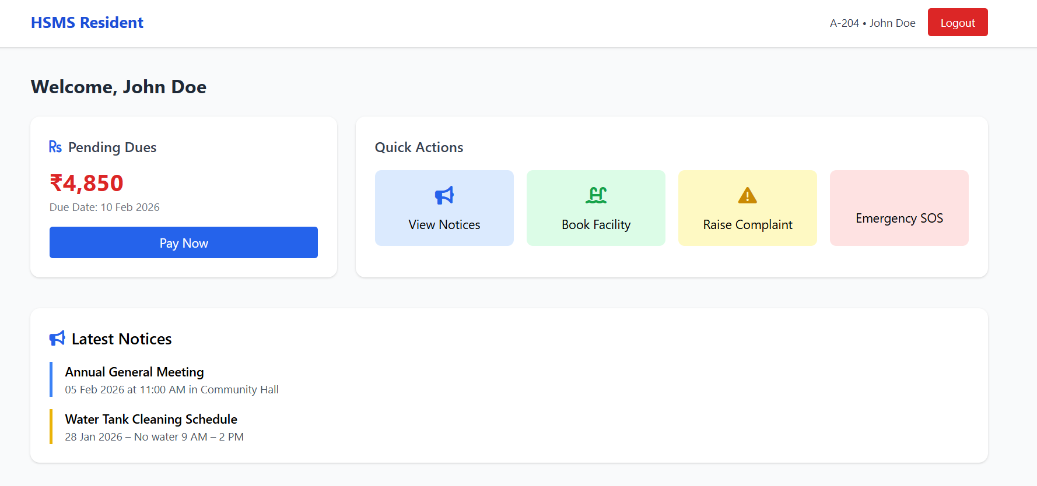

Test Cases

TC_01: Admin Login
Field | Description
Test Case ID | TC_01
Test Case Title | Admin Login Authentication
Preconditions | Admin account exists in the system
Postconditions | Admin is logged into the system
Actions | 1. Open login page  2. Enter valid Admin email and password  3. Click Login button
Expected Results | Admin dashboard is displayed, session is active
Tested By | F25PROJECT610E7
Result | Pass

TC_02: Admin Update Profile
Field | Description
Test Case ID | TC_02
Test Case Title | Update Admin Profile Information
Preconditions | Admin logged in
Postconditions | Admin profile updated successfully
Actions | 1. Navigate to profile settings  2. Edit Name, Contact, or Password  3. Click Save
Expected Results | Profile changes are saved and reflected in the system
Tested By | F25PROJECT610E7
Result | Pass

TC_03: Create Resident
Field | Description
Test Case ID | TC_03
Test Case Title | Add New Resident to the System
Preconditions | Admin logged in
Postconditions | Resident record created in the database
Actions | 1. Navigate to Residents module  2. Click Add Resident  3. Fill details and assign unit  4. Click Save
Expected Results | Resident record created successfully and listed in directory
Tested By | F25PROJECT610E7
Result | Pass

TC_04: Update Resident
Field | Description
Test Case ID | TC_04
Test Case Title | Edit Resident Details
Preconditions | Resident exists in the system
Postconditions | Resident details updated
Actions | 1. Navigate to Residents list  2. Select a resident  3. Update information  4. Save changes
Expected Results | Updated information is stored and displayed
Tested By | F25PROJECT610E7
Result | Pass

TC_05: Assign Resident to Unit
Field | Description
Test Case ID | TC_05
Test Case Title | Assign Resident to Unit
Preconditions | Unit exists and resident exists
Postconditions | Resident linked to the unit
Actions | 1. Navigate to Units module  2. Select unit  3. Assign resident as owner/tenant  4. Save
Expected Results | Unit shows resident ownership/tenancy
Tested By | F25PROJECT610E7
Result | Pass

TC_06: Create Staff/Vendor
Field | Description
Test Case ID | TC_06
Test Case Title | Add Staff or Vendor
Preconditions | Admin logged in
Postconditions | Staff/vendor record created
Actions | 1. Navigate to Staff/Vendor module  2. Click Add  3. Fill details  4. Save
Expected Results | Staff/vendor listed and entry code generated
Tested By | F25PROJECT610E7
Result | Pass

TC_07: Generate Bill
Field | Description
Test Case ID | TC_07
Test Case Title | Create Maintenance or Utility Bill
Preconditions | Unit exists
Postconditions | Bill added to the system
Actions | 1. Navigate to Bill module  2. Select Unit  3. Enter amount, type, due date  4. Save
Expected Results | Bill generated and visible to the resident
Tested By | F25PROJECT610E7
Result | Pass

TC_08: Record Payment
Field | Description
Test Case ID | TC_08
Test Case Title | Record Dummy Online Payment
Preconditions | Bill exists and resident assigned
Postconditions | Payment recorded
Actions | 1. Open Payment module  2. Select Bill  3. Enter dummy payment details  4. Save
Expected Results | Bill status updated to Paid
Tested By | F25PROJECT610E7
Result | Pass

TC_09: View Income/Expense Report
Field | Description
Test Case ID | TC_09
Test Case Title | Generate Income vs Expense Report
Preconditions | Bills and expenses exist
Postconditions | Report generated
Actions | 1. Navigate to Reports module  2. Select Income/Expense report  3. Click Generate
Expected Results | Correct report displayed with totals
Tested By | F25PROJECT610E7
Result | Pass

TC_10: Create Complaint
Field | Description
Test Case ID | TC_10
Test Case Title | File Resident Complaint
Preconditions | Resident exists
Postconditions | Complaint added to system
Actions | 1. Navigate to Complaint module  2. Fill category and description  3. Submit
Expected Results | Complaint status is Pending and visible to Admin
Tested By | F25PROJECT610E7
Result | Pass

TC_11: Assign Complaint
Field | Description
Test Case ID | TC_11
Test Case Title | Admin Assign Complaint to Staff/Vendor
Preconditions | Complaint exists
Postconditions | Staff/vendor assigned
Actions | 1. Navigate to Complaints  2. Select complaint  3. Assign staff/vendor  4. Save
Expected Results | Complaint shows assigned staff/vendor
Tested By | F25PROJECT610E7
Result | Pass

TC_12: Update Complaint Status
Field | Description
Test Case ID | TC_12
Test Case Title | Update Complaint Status
Preconditions | Complaint exists and assigned
Postconditions | Status updated
Actions | 1. Open complaint  2. Change status to In Progress/Resolved  3. Save
Expected Results | Status updated in system
Tested By | F25PROJECT610E7
Result | Pass

TC_13: Create Notice
Field | Description
Test Case ID | TC_13
Test Case Title | Admin Publish Notice
Preconditions | Admin logged in
Postconditions | Notice visible to residents
Actions | 1. Open Notice module  2. Click Add Notice  3. Enter title, content, type, priority  4. Publish
Expected Results | Notice visible to residents, active flag set
Tested By | F25PROJECT610E7
Result | Pass

TC_14: Create Poll
Field | Description
Test Case ID | TC_14
Test Case Title | Admin Create Poll
Preconditions | Admin logged in
Postconditions | Poll active with options
Actions | 1. Navigate to Poll module  2. Click Add  3. Enter title, type, start/end date, options  4. Save
Expected Results | Poll active and residents can vote
Tested By | F25PROJECT610E7
Result | Pass

TC_15: Create Amenity
Field | Description
Test Case ID | TC_15
Test Case Title | Add New Amenity
Preconditions | Admin logged in
Postconditions | Amenity added
Actions | 1. Navigate to Amenities module  2. Click Add  3. Enter name, capacity, booking fee  4. Save
Expected Results | Amenity visible in booking list
Tested By | F25PROJECT610E7
Result | Pass

TC_16: Approve Amenity Booking
Field | Description
Test Case ID | TC_16
Test Case Title | Admin Approves Amenity Booking
Preconditions | Booking requested by resident
Postconditions | Booking confirmed
Actions | 1. Navigate to Bookings  2. Select booking  3. Approve/Auto-confirm
Expected Results | Booking status updated to Confirmed
Tested By | F25PROJECT610E7
Result | Pass

TC_17: Security Guard Login
Field | Description
Test Case ID | TC_17
Test Case Title | Guard Authentication
Preconditions | Guard account exists
Postconditions | Guard session active
Actions | 1. Open login page  2. Enter credentials  3. Click Login
Expected Results | Guard dashboard opens, shift info visible
Tested By | F25PROJECT610E7
Result | Pass

TC_18: Register Visitor Entry
Field | Description
Test Case ID | TC_18
Test Case Title | Log Visitor Entry
Preconditions | Guard logged in
Postconditions | Visitor entry recorded
Actions | 1. Navigate to Visitor module  2. Enter visitor details and unit  3. Save entry
Expected Results | Visitor check-in time recorded
Tested By | F25PROJECT610E7
Result | Pass

TC_19: Register Visitor Exit
Field | Description
Test Case ID | TC_19
Test Case Title | Log Visitor Exit
Preconditions | Visitor is checked in
Postconditions | Check-out time recorded
Actions | 1. Select visitor  2. Click Checkout  3. Confirm exit
Expected Results | Visitor exit time updated
Tested By | F25PROJECT610E7
Result | Pass

TC_20: Guard Patrol Logging
Field | Description
Test Case ID | TC_20
Test Case Title | Record Patrol Activity
Preconditions | Guard logged in and assigned route
Postconditions | Patrol log recorded
Actions | 1. Navigate to Patrol module  2. Start patrol  3. Complete patrol  4. Save log
Expected Results | Patrol record stored in system
Tested By | F25PROJECT610E7
Result | Pass

TC_21: Resident Login
Field | Description
Test Case ID | TC_21
Test Case Title | Resident Authentication
Preconditions | Resident account exists
Postconditions | Resident session active
Actions | 1. Open login page  2. Enter credentials  3. Click Login
Expected Results | Resident dashboard opens
Tested By | F25PROJECT610E7
Result | Pass

TC_22: View Unit Details
Field | Description
Test Case ID | TC_22
Test Case Title | Resident Views Unit Info
Preconditions | Resident logged in
Postconditions | Unit information displayed
Actions | 1. Navigate to Unit module  2. Select own unit
Expected Results | Display block, floor, size, status, ownership type
Tested By | F25PROJECT610E7
Result | Pass

TC_23: View Bills
Field | Description
Test Case ID | TC_23
Test Case Title | Resident Views Bills and History
Preconditions | Resident logged in, bills exist
Postconditions | Bills displayed
Actions | 1. Navigate to Bills module  2. Select Bill type  3. View details
Expected Results | Show amount, due date, status
Tested By | F25PROJECT610E7
Result | Pass

TC_24: Pay Bill
Field | Description
Test Case ID | TC_24
Test Case Title | Resident Pays Bill (Dummy)
Preconditions | Unpaid bill exists
Postconditions | Payment recorded
Actions | 1. Select unpaid bill  2. Choose dummy payment method  3. Submit payment
Expected Results | Bill status updated to Paid, receipt available
Tested By | F25PROJECT610E7
Result | Pass

TC_25: Raise Complaint
Field | Description
Test Case ID | TC_25
Test Case Title | Resident Files Complaint
Preconditions | Resident logged in
Postconditions | Complaint added to system
Actions | 1. Navigate to Complaints  2. Enter category and description  3. Submit
Expected Results | Complaint visible to admin, status Pending
Tested By | F25PROJECT610E7
Result | Pass

TC_26: Book Amenity
Field | Description
Test Case ID | TC_26
Test Case Title | Resident Books Amenity
Preconditions | Amenity available, Resident logged in
Postconditions | Booking created
Actions | 1. Open Amenity module  2. Select time slot  3. Submit booking
Expected Results | Booking confirmed or pending approval
Tested By | F25PROJECT610E7
Result | Pass

TC_27: View Notices
Field | Description
Test Case ID | TC_27
Test Case Title | Resident Views Notices and Alerts
Preconditions | Notices exist
Postconditions | Notices displayed
Actions | 1. Navigate to Notices module  2. View active notices and emergency alerts
Expected Results | Correct notices visible based on priority
Tested By | F25PROJECT610E7
Result | Pass

TC_28: Trigger SOS
Field | Description
Test Case ID | TC_28
Test Case Title | Resident SOS Emergency Alert
Preconditions | Resident logged in
Postconditions | SOS sent to security/admin and emergency contacts
Actions | 1. Click SOS button  2. Confirm action
Expected Results | Alert delivered instantly to responsible personnel
Tested By | F25PROJECT610E7
Result | Pass

TC_29: Guard Receives SOS
Field | Description
Test Case ID | TC_29
Test Case Title | Security Guard Responds to SOS
Preconditions | SOS triggered by resident
Postconditions | Emergency logged and response initiated
Actions | 1. Guard dashboard receives SOS  2. Acknowledge  3. Respond or notify admin
Expected Results | SOS handled, incident recorded
Tested By | F25PROJECT610E7
Result | Pass

TC_30: Generate Defaulter List
Field | Description
Test Case ID | TC_30
Test Case Title | Admin Generates Defaulter Report
Preconditions | Some residents have unpaid bills
Postconditions | Defaulter list created
Actions | 1. Navigate to Reports module  2. Click Generate Defaulter List  3. View/Export
Expected Results | List shows residents with unpaid bills
Tested By | F25PROJECT610E7
Result | Pass

